Four Bulletin Announcements from Alongside Hope to Share with Your Church
Help Light the Way for Women and Babies in Mozambique and Madagascar
Imagine giving birth in the dark, with only a flashlight or cell phone for light. That’s the reality for many women in rural clinics across Mozambique and Madagascar. But it doesn’t have to be. Alongside Hope’s Solar Suitcase project equips these clinics with solar-powered kits, bringing bright light, vital medical tools, and peace of mind. Every gift made by October 31 is being matched up to $150,000, so your impact can go even further. Please give today.
Visit alongsidehope.org/solar-suitcase or call 1-866-308-7973 to learn more or donate.
Alongside Hope: Double the Light. Double the Hope.
A Solar Suitcase costs $6,500 to produce, deliver and install, and every gift made by October 31 is being matched, up to $150,000.00. That means a $100 gift becomes $200 of life-changing support to off-grid clinics in Mozambique and Madagascar. Your generosity powers lights, a fetal doppler, and more—giving midwives what they need to safely care for women giving birth and newborns. Let’s turn on the power for safe births, together.
Give today at alongsidehope.org/solar-suitcase or call 1-866-308-7973.
Pray, Act, Give: Alongside Hope with Light
"God who proclaimed, 'Let there be light,' who saw that the light was good, be with those who bring light into the world..."
Let us pray for the labouring women and the midwives who care for them across Mozambique and Madagascar. Let us pray for the babies and their safe delivery. Let us act by joining Alongside Hope’s Wild Ride or supporting those who do. And let us give to support Alongside Hope’s solar suitcase campaign, because together we can make a difference. Every gift made by October 31 will be matched, up to $150,000.00.
To give or learn more visit: alongsidehope.org/solar-suitcase or call 1 866 308 7973.
The Wild Ride: Move with Purpose
Whether you walk, cycle, knit, sing, your favourite activity can help women and babies across Mozambique and Madagascar. Alongside Hope’s Wild Ride is a do-it-your-way fundraiser that supports Solar Suitcases for clinics without electricity. Every step, stitch, or song helps bring safe light to birthing clinics in Mozambique and Madagascar. Every gift made by October 31 is being matched, up to $150,000.00.
Learn more or join in at alongsidehope.org/wild-ride or call 1-866-308-7973.
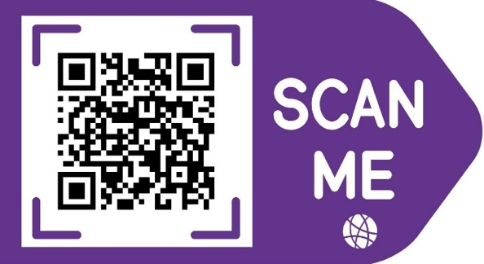
Please use this QR code image in your bulletin with each of the above announcements or your own Solar Suitcase announcement. It takes people to Alongside Hope’s Solar Suitcase webpage where they can learn more.

